

Support Ticketing System

by

Ilkay Ates, Marcia Luna, Marcus Ritter, Shamil Fayzullin

SRH University Heidelberg
Faculty of Information, Media and Design
Applied Computer Science
Software Architecture and Development

Submission Date: 11.05.2017

Reviewer: Christoph Hahn M.Sc.
Document History

Table 1 Document history
Version | Date | Change
1.0 | 24.04.2017 | Draft version prepared

Table of Content

1 About this Document 7
1.1 Authors 7
1.2 Project Scope 7
1.3 Document Structure 8
1.4 Glossary 8
2 Design Thinking 11
2.1 Students 11
2.1.1 Persona 11
2.1.2 Experience journey 12
2.2 Support Team Member 12
2.2.1 Persona 12
2.2.2 Experience journey 13
2.3 Support Team Manager 14
2.3.1 Persona 14
2.3.2 Experience journey 15
3 Software Requirements 17
3.1 Business Requirements 17
3.2 User Stories 18
3.3 User Interfaces 18
3.4 Roles and Authorizations 19
4 Solution 20
4.1 Solution Overview 20
4.2 User Interfaces 22
4.2.1 Student 22
4.2.2 Support Team Member 30
4.2.3 Support Team Manager 40
4.3 Roles and Authorizations 44
4.4 Database diagram (ERM) 46
5 References 48

List of Figures

Figure 1 Solution architecture 20
Figure 2 Fiori Launchpad 23
Figure 3 Home Screen for Student 23
Figure 4 Predefined Support Solution Categories 24
Figure 5 List of Predefined Support Solutions 25
Figure 6 Predefined Support Solution 26
Figure 7 List of My Tickets 27
Figure 8 Ticket Details 28
Figure 9 Feedback 29
Figure 10 Login 31
Figure 11 Home Screen for Support Team Members 32
Figure 12 Solution Category Maintenance 33
Figure 13 Solution Category Details 33
Figure 14 New Solution Category 34
Figure 15 Predefined Support Solution Maintenance 35
Figure 16 Predefined Support Solutions Maintenance 2 36
Figure 17 Predefined Support Solutions 37
Figure 18 New Support Solution 38
Figure 19 Open Tickets List 39
Figure 20 Open Ticket Details 39
Figure 21 Login 40
Figure 22 Home Screen for Support Team Manager 41
Figure 23 Overdue Tickets List 42
Figure 24 Overdue Ticket Details 42
Figure 25 Overdue Ticket Responsible Selection 43
Figure 26 Overdue Ticket Assignment 43
Figure 27 Team Performance Analytics 44
Figure 28 Roles and Authorizations 45
Figure 29 ERM Support Ticketing System 46

List of Tables

Table 1 Document history 2
Table 2 Authors 7
Table 3 Glossary 8
Table 4 Business requirements 17
Table 5 Work tasks according to their business roles 19

About this Document

Authors
Table 2 Authors
Name | Project Role
Ates, Ilkay | Business Analysis, Frontend Development
Luna, Marcia | Mock-Up Design, Frontend Development
Ritter, Marcus | Software Architecture, Frontend Development
Fayzullin, Shamil | Project Management, Backend Development

Project Scope
Regarding the support requests of students in the previous years, necessity of a support ticketing system application has been established. This application is designed as a platform where students will find a variety of predefined solutions and additionally, they will have the possibility to create new tickets regarding their needs. There are three user types in this application: student, support team member and support team manager.
Students can search and view predefined solutions which will be organized by categories. In case they cannot find solutions regarding their requests or questions, they can create new tickets. After a ticket has been resolved the student will be asked to fill a satisfaction questionnaire. This will provide the rating of the support and will be used for analytics to improve the system.
Support team members can create and edit solution categories which are necessary to facilitate solution search for students. They can create and edit predefined solutions and resolve tickets which are created by students. Number of open tickets with a link to the list will be displayed on the initial screen of support team member, this will provide an easy insight to reach the waiting requests.
Support team manager will be able to view all tickets. On the initial screen, a link to overdue tickets which are not responded within 48 hours will be displayed. Support team manager can assign these tickets to support team members. Additionally, analytics will be provided for support team manager which can be filtered for a specific period and/or responsible support team member. Different analytics will be displayed based on the ticket status or ratings of the provided solution.

Document Structure
This document is structured as follows:
Chapter 1 of this document includes project scope and formal aspects about the project and team members.
Chapter 2 describes the design thinking with methods of personas and user experience journeys.
Chapter 3 includes software requirements.
Chapter 4 describes the solution in relation to requirements described in chapter 3.
Chapter 5 provides a list of references.

Glossary
Table 3 Glossary
Term | Abbreviation | Definition
SAP Cloud Platform |  | SAP HANA Cloud Platform is an in-memory cloud platform based on open standards. It provides access to a feature-rich, easy-to-use development environment in the cloud. The platform includes a comprehensive set of services for integration, enterprise mobility, collaboration, and analytics. (SAP, 2016b)
SAPUI5 |  | JavaScript UI library that is maintained by SAP SE and based on the HTML5 standard. Used for building mobile and desktop applications running in a browser. (Andreas Kunz, 2013)
Fiori |  | Fiori applications are built with SAPUI5. SAP Fiori apps follow the SAP Fiori Design Guidelines (framework) to ensure consistent design and a high level of design quality and at the same time allow porting to mobile devices. For more information, please see https://experience.sap.com/fiori-design/. (SAP, 2017e)
OData protocol | OData | OData (Open Data Protocol) is an OASIS standard that defines a set of best practices for building and consuming RESTful APIs. (ODATA, 2015)
SAP Adaptive Server Enterprise | SAP ASE DB | SAP ASE is a high performance relational model SQL database server optimized for transaction-based applications (OLTP), originally developed by Sybase Corporation. (SAP, 2017b)
SAP NetWeaver |  | SAP NetWeaver is the on-premise technical foundation for the SAP Business Suite and for the on-premise edition of SAP S/4HANA. The NetWeaver Application Server serves as runtime environment for the SAP applications and the Business Suite solutions. (Karl Kessler, 2015)
Hana Cloud Connector | HCC | Now also known as SAP Cloud Platform cloud connector, it serves as the link between on-demand applications in SAP Cloud Platform and existing on-premise systems. The cloud connector acts like a reverse invoke proxy between the on-premise network and the SAP Cloud Platform, while it runs as a on-premise agent in a secured network. (SAP, 2017c)

Design Thinking

Students

Persona
Jane is a master student with a Bachelor degree in business administration. She has average computer skills, so she needs some technical support when she has to deliver assignments for her lectures for which she needs to use some applications. She also needs help to get an access for the student portal where all her lecture’s content is published.
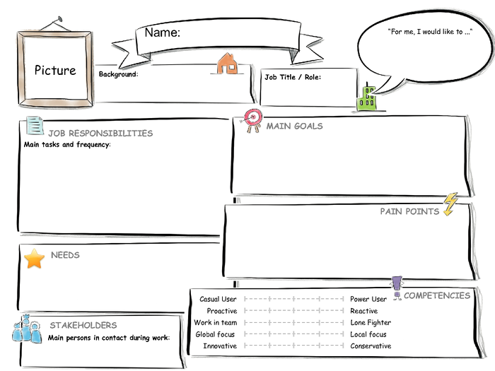
Get lecture content,
deliver assignments/lecture projects on time,
pass exams
Support team member
I would like to get technical support during my master program
Master Student
Jane
Bachelor degree in business administration, first semester in master program, average computer skills
I need support to prepare projects with software tools, to access online student portal
Attend lectures on time,
prepare and deliver assignments/projects,
sign in for exams, c
heck exam results
Lack of technical skills to deliver assignments/projects

Experience journey
A student needs the content of his lecture. To reach the content he needs access to student portal. He thinks of getting the content from a classmate but decides to ask for access to support team, because he will need it for the rest of his studies. He is concerned of being already late and considers talking to the teacher. After sending an email to support team he waits for a response. Next day he receives a response which describes how to get access to the portal.
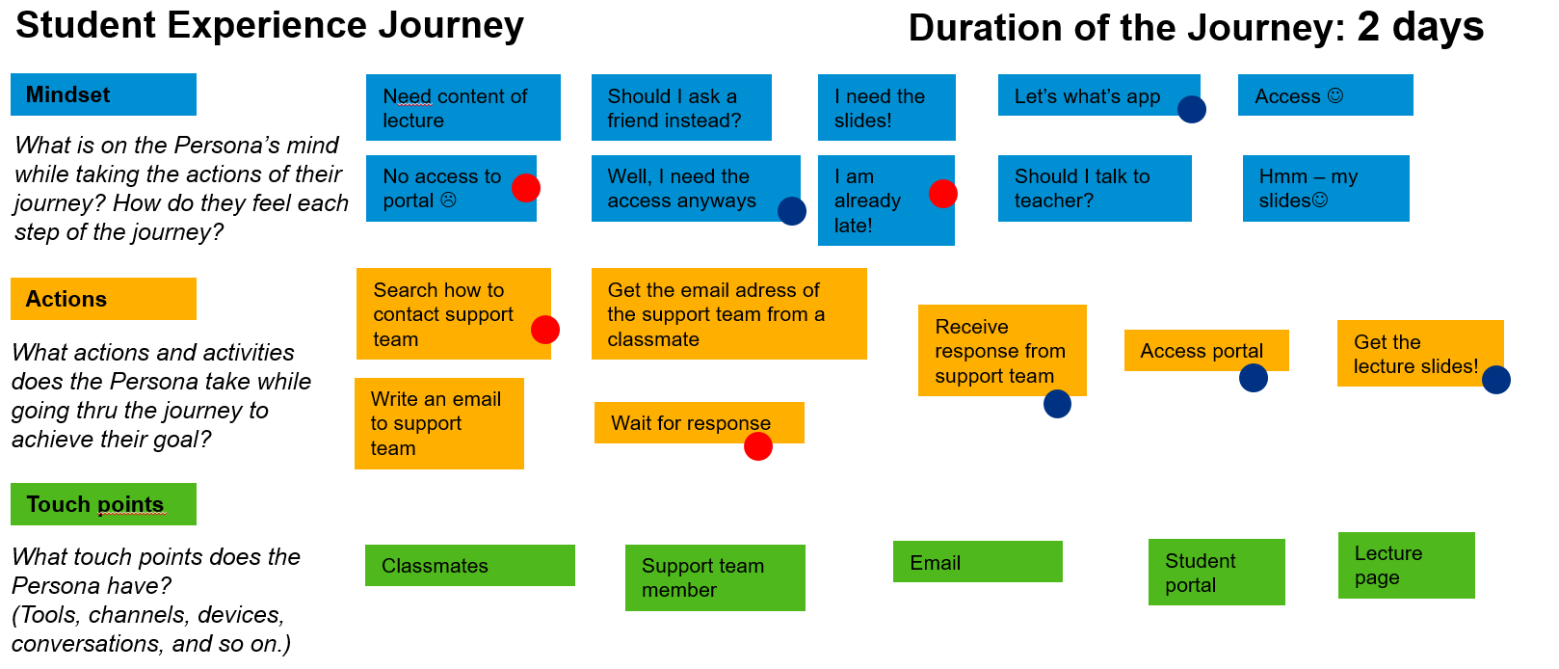

Support Team Member

Persona
Marc is a member of support team. He studied information systems and has 3 years of work experience in IT departments of several companies. He would like to achieve high performance on delivering support on time. To reduce his response time to the requests, a dashboard with a list of open tickets would be very helpful for him. The strongest pain point for him is the communication with the requester. He needs a platform where he can see all communication history to follow up the case easier.
Resolve issues of students within 24 hours
Students,
Support team manager
I would like to achieve high performance on delivering support on time to students
Support Team Member
Marc
Studied information systems, worked 3 years in it department, very good computer skills
I need a dashboard to see new and open tickets, a platform that I can contact the requester.
Provide support/information to students

Lack of sufficient information about the support needed, lack of notification on time.

Experience journey
Support team member opens his mailbox to read the support mails. He has to read them to find out which one is more urgent. In some cases he needs extra information from the requester and waits for his response to solve the issue. When he has all necessary information, he sends the solution to the requester and waits for his confirmation.
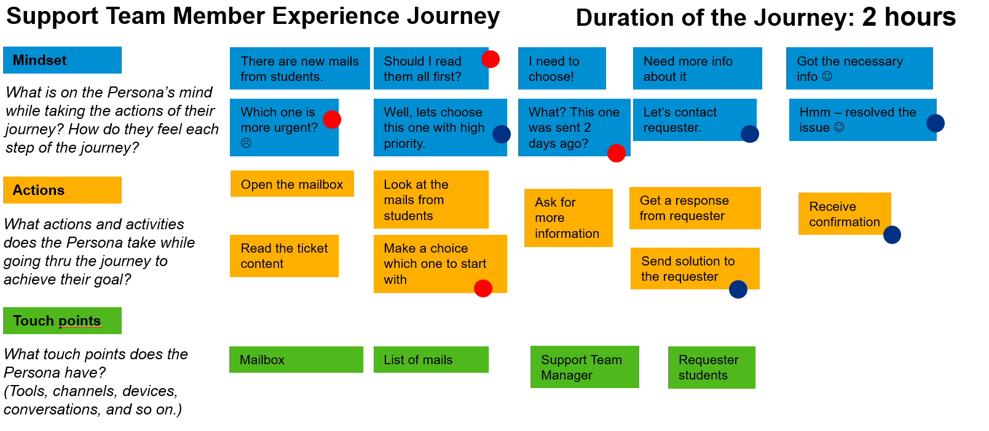

Support Team Manager

Persona
Albert is the support team manager. He studied information systems and worked for 8 years in IT and support departments of several companies. His goal is to improve efficiency and effectiveness of support team. He needs a real time insight for overdue requests so that he can assign them manually to avoid late support. He spends much time to create performance reports so analytics will facilitate his job to review performance of his team.
Reduce response time for support requests,
Reduce overdue support requests,
Improve support for students
Support team members,
Students
I would like to improve efficiency and effectiveness of support team
Support Team Manager
Albert
Studied information systems, worked 8 years in it and support departments, very good computer and management skills
I need to reduce response time for support requests, I need realtime insight of support team activities
Oversee daily support activities, handle overdue support requests,
supervise support team members,
manage support team performance
Excessive time spent to create reports of support team activities,
Late insight into overdue support requests

Experience journey
Support team manager opens his mailbox to follow up on overdue tickets. He needs to check every mail to find out if it is in process or still waiting. For the requests which are overdue, he assigns them to the available support team member. To view performance results of the team he needs to create reports manually and read feedback mails from students.
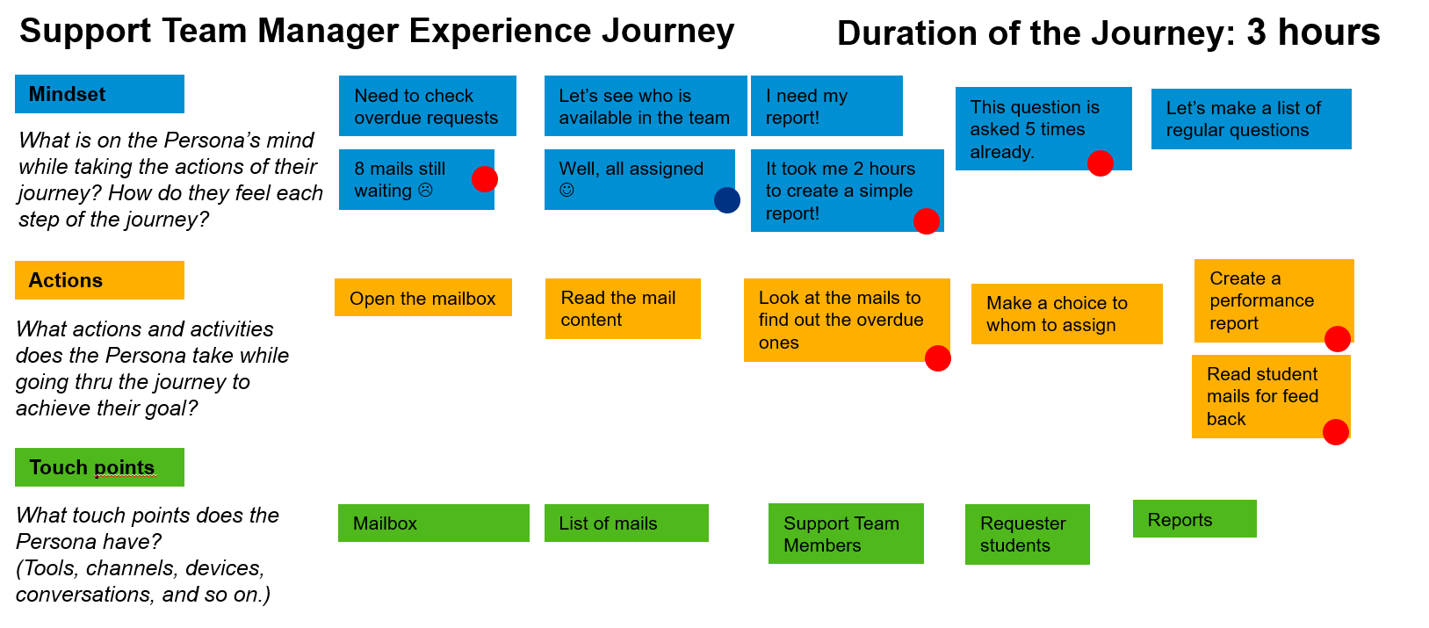

Software Requirements

Business Requirements
Table 4 Business requirements
№ | Requirement | Necessity
1 | The Support Ticketing System should support the creation and maintenance of predefined solution categories. | Must have
2 | The Support Ticketing System should provide functionality to create predefined support solutions and to categorize them. | Must have
3 | The Support Ticketing System should support the creation of new support tickets. | Must have
4 | For the process flow of a support ticket, the Support Ticketing System should support status changes of the ticket. | Must have
5 | The support Ticketing System should provide notifications for the students, which will be displayed on initial screen and provide the number of tickets to be confirmed. | Nice to have
6 | The support Ticketing System should provide notifications for the support team members, which will be displayed on initial screen and provide the number of open tickets. | Nice to have
7 | The support Ticketing System should support support manager to assign tickets to support team members. | Must have
8 | The support Ticketing System should provide notifications for the support manager, which will be displayed on initial screen and provide the number of overdue tickets that are not being process within 48 hours. | Nice to have
9 | After a ticket is been resolved, the Support Ticketing System should provide a questionnaire to gather the rating of the provided support. | Nice to have
10 | The Support Ticketing System should provide analytics for support manager which will be filtered based on ticket status or rating of support team members. | Nice to have

User Stories
As a | I want to… | so that…
student | search for support solutions | I can find solutions for my issues.
student | create new tickets | I can get support for my issues which I cannot solve with predefined support solutions.
student | see a list of my tickets | I can follow up their status and view provided responses.
support team member | create support solution categories | I can categorize the support solutions.
support team member | create support solutions | I will not need to provide support for the same issues repeatedly.
support team member | see a list of open tickets | I can provide support on time.
support team manager | assign overdue tickets | I can reduce tickets which are waiting for support since more than 48 hours.
support team manager | see a list of overdue tickets | I can assign them.
support team manager | view analytics | I can have an insight of team performance.

User Interfaces
Support Ticketing System should comply with the following requirements:
- Support Ticketing System should support use of the following web browsers (IE, Chrome, Edge).
- Support Ticketing System should be used on PC, tablets and smartphones.
- Support Ticketing System should be based on HTML5.
- Support Ticketing System should follow user-friendly interface design principals.

Roles and Authorizations
Support Ticketing System should support a role-based authorizations and access control. This system will be used by different users that can have the following roles based on associated scenarios and authorizations:
- Student
- Support Team Member
- Support Manager

The following table describes typical work tasks for each business role in more detail:

Table 5 Work tasks according to their business roles
Student | Support Team Member | Support Team Manager
- Create new ticket  - Response ticket  - Confirm ticket  - Give feed-back for provided support  - Search predefined solutions | - Create predefined solution categories  - Create predefined solutions  - Resolve Tickets | - Assign Tickets  - Display Analytics

Solution

Solution Overview
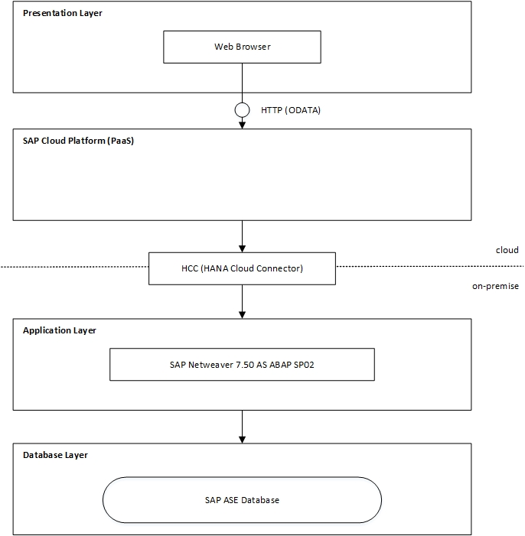
Figure 1 Solution architecture
The Support Ticketing System uses three tier client-server architecture pattern and therefore consists of three layers: presentation layer, application layer and data layer. Additionally, SAP Cloud Platform as a PaaS comes into play. The use of this architecture allows the development of the user-interface, business logic and database layer as independent modules. This also makes it possible to have the different layers on separate platforms using different technologies. In case an update is necessary only the effected layer needs to be updated or replaced without influencing the other ones. (Wikipedia, 2017) The idea behind this architecture was taken according to the SAP courses SAPUI5 and Build your own SAP Fiori app in the cloud. (Raz Korn, 2016) (Janina Bläsius, 2016)

Presentation layer:
The presentation layer is directly accessed by the user and presents the information computed or provided by the application, other layers. In this case the user accesses through a browser a SAPUI5 application which presents him the information processed by the business logic. The client side application uses the OData Protocol to communicate with the SAP Cloud Platform per REST Api (Http calls). (ODATA, 2015)

SAP Cloud Platform and HCC:
The SAP HANA Cloud Platform is an in-memory cloud platform based on open standards. It is a PaaS (Platform as a Service) that offers a comprehensive set of services for integration, enterprise mobility, collaboration and analytics. In this case SAP Cloud platform is used for client side application development with SAPUI5, Fiori and hosting the developed services, so that they can be accessed by the users.
The HCC (Hana Cloud Connector) serves as the link between the on-demand applications hosted on the SAP Cloud Platform and the existing on-premise system these applications need to be connected to.

Application layer:
The application layer contains the business logic of the application and controls the functionality. In this case the application layer consists of a on-premise SAP NetWeaver 7.5 system, which is connected via the HCC to the on-demand hosted SAPUI5 applications on the SAP Cloud Platform. The SAP NetWeaver builds the technical foundation and brings the runtime environment for the ABAP backend of the application, that’s is running on this system.

Data layer:
The database layer stores data persistently and makes it available to the services and applications which want to access it. In this case a SAP Adaptive Server Enterprise (ASE) relational model SQL database server is used. The ABAP backend in the SAP NetWeaver will accesses the ASE database server and get the needed data and process it for the client side of the application.

User Interfaces
In order to meet the customer’s user interface requirements, the SAP Fiori design guidelines were applied (SAP, 2017e). Additionally, SAP Design Stencils for Microsoft PowerPoint were used to create low-fidelity Wireframes and in a second step enhanced to Visual Designs (SAP, 2016a). Furthermore a high-fidelity prototype was created with build.me (SAP, 2017a). According to this high-fidelity prototype the Support Ticketing System will be developed using the SAP Fiori framework. This framework is based on SAPUI5 libraries (HTML5) which allow the creation of responsive interfaces for different types of devices like laptops, mobiles, PCs and browsers e.g. IE, Chrome or Edge. The pursued approach and used methodology is based on the SAP Course “Build your own SAP Fiori App in the Cloud – 2016 Edition” (Raz Korn, 2016).
The high-fidelity prototype does not cover any possible use case scenario (changes during implementation phase are likely to happen). Nevertheless, it shows the key functionality of the Support Ticketing System and provides an example for the look and feel of the finalized user interface. The following subsections present three basic usage scenarios in respect of the different user groups: Students, Support Team Members, Support Team Managers.

Student

Login
Following figure displays the login screen of the Support Ticketing System. Based on the entered user credentials, role of the user will be identified and next screen will be displayed based on the role of the user.
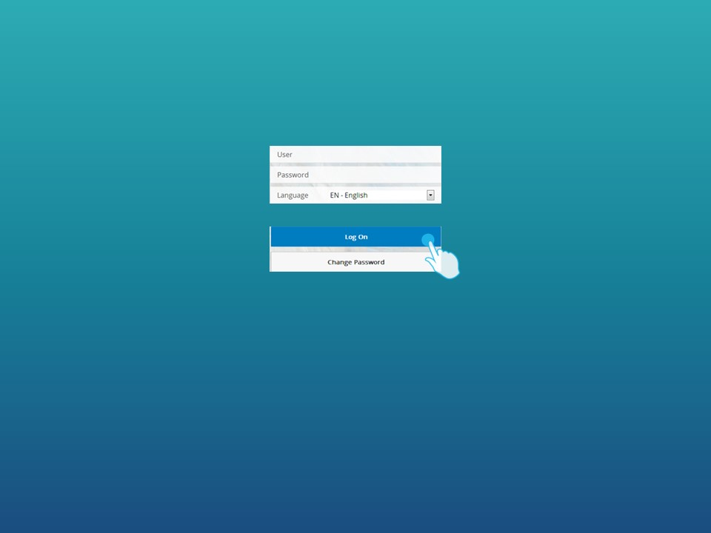
Figure 2 Fiori Launchpad

My Home
On the initial screen of student, three links will be displayed; predefined solutions, tickets created by the student and new ticket.
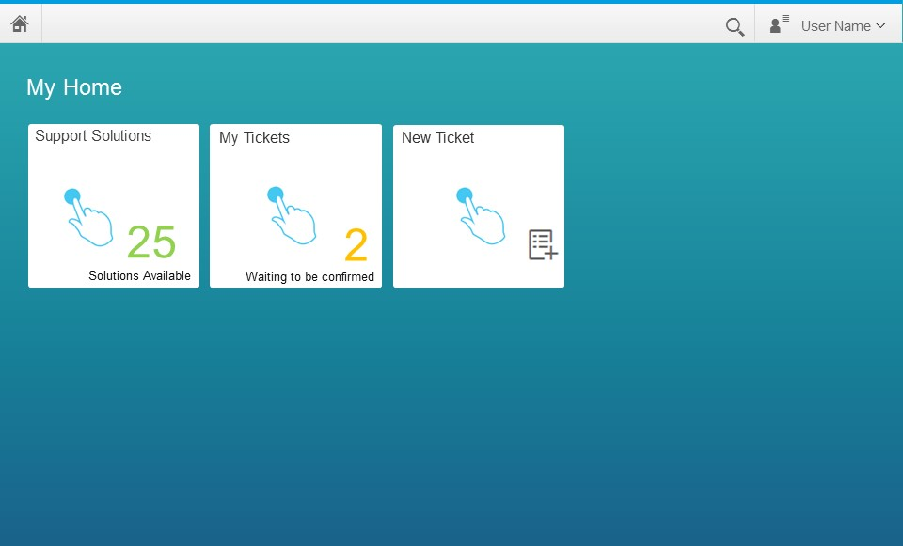
Figure 3 Home Screen for Student

Support Solutions
This screen consists of two panes. On the left pane, categories which include predefined support solutions will be displayed. Based on the choice of student, a list of predefined support solutions which belong to the related category will be displayed on the right pane.
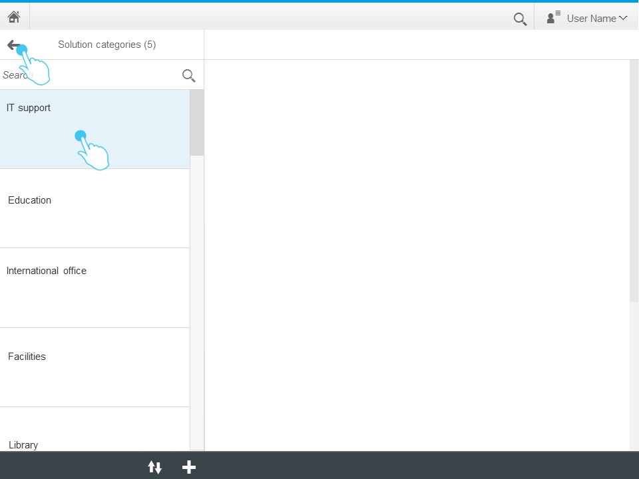
Figure 4 Predefined Support Solution Categories
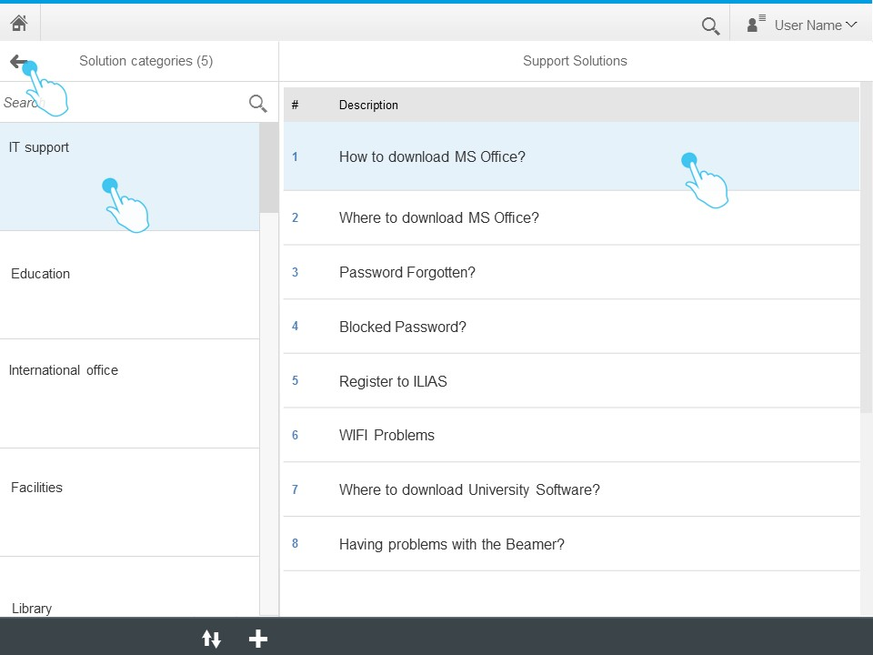
Figure 5 List of Predefined Support Solutions

Based on the choice of student, the content of selected predefined support solution will be displayed on the right pane.
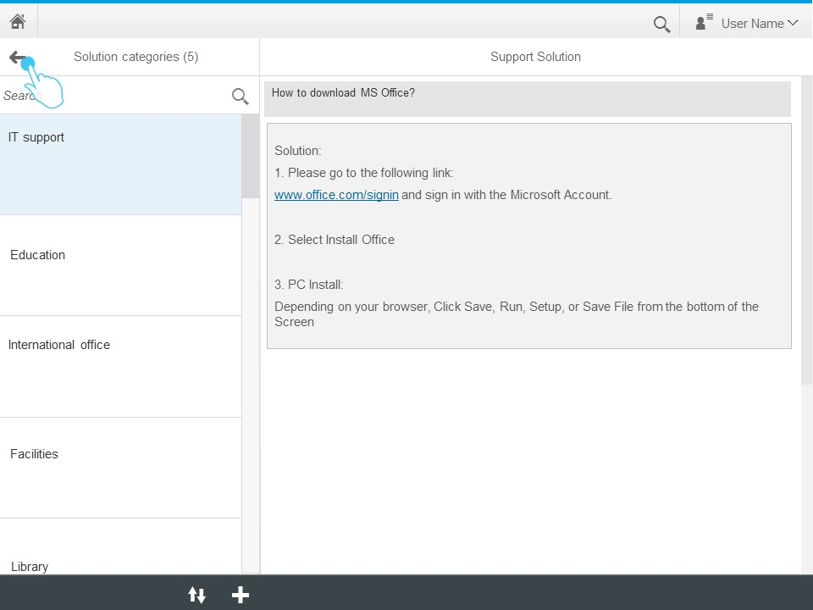
Figure 6 Predefined Support Solution

My Tickets
My Tickets screen consist of two panes; on the left pane, the list of tickets which are created by the student will be displayed. On the header, the number of tickets will be provided. Each ticket number will be listed with the current status of the ticket.
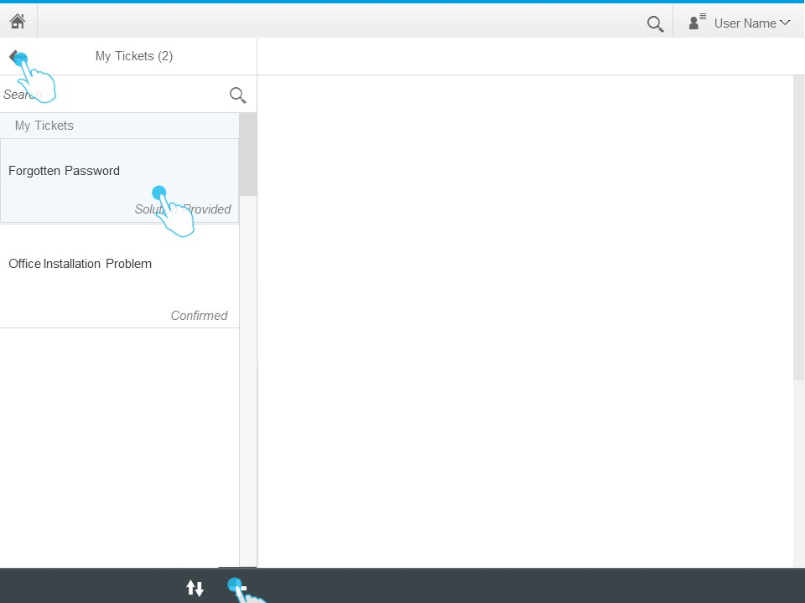
Figure 7 List of My Tickets

When the student clicks on of the tickets on the list, the details of this ticket will be displayed on the right pane. Based on the status of the ticket, student will be able to send a response or confirm the ticket.
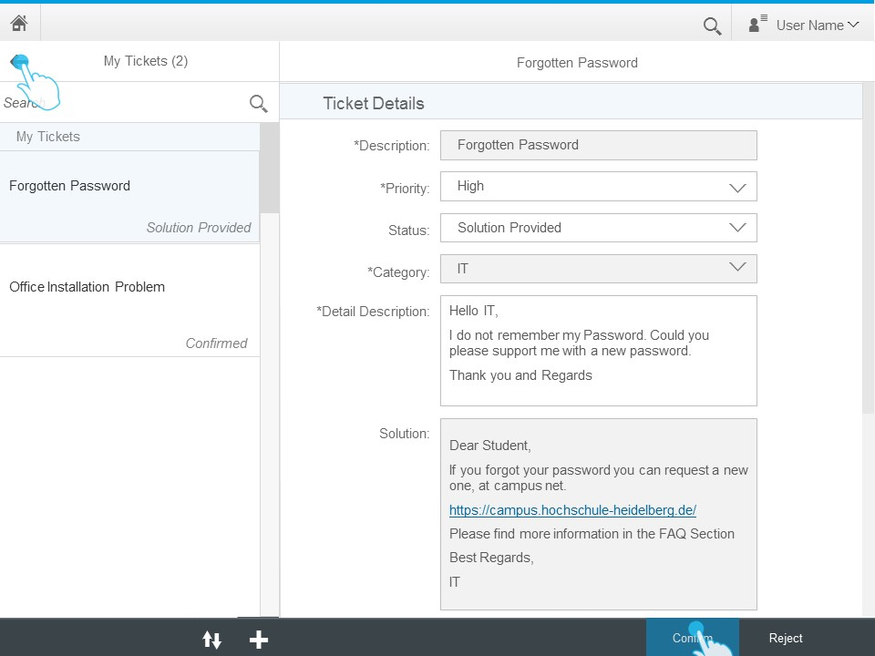
Figure 8 Ticket Details

Feedback
After a ticket is confirmed by the student, a feed back questionnaire will be displayed on the right pane. The rating given by the student for the provided support will be saved for analytics which will be provided to support team manager.

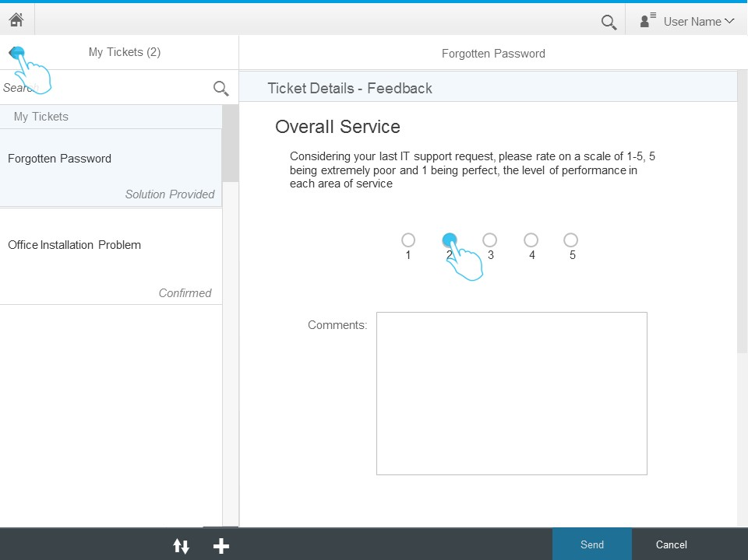
Figure 9 Feedback

New Ticket
On the New Ticket screen, following fields will be displayed:
Description: Short title, which will describe the content of the ticket.
Priority: A list with three options: low, medium, high.
Status: Disabled field to display the status of the ticket.
Category: Category of the ticket, which can be edited also by the support team members.
Issue Detail Description: Detailed description of the issue which needs support.

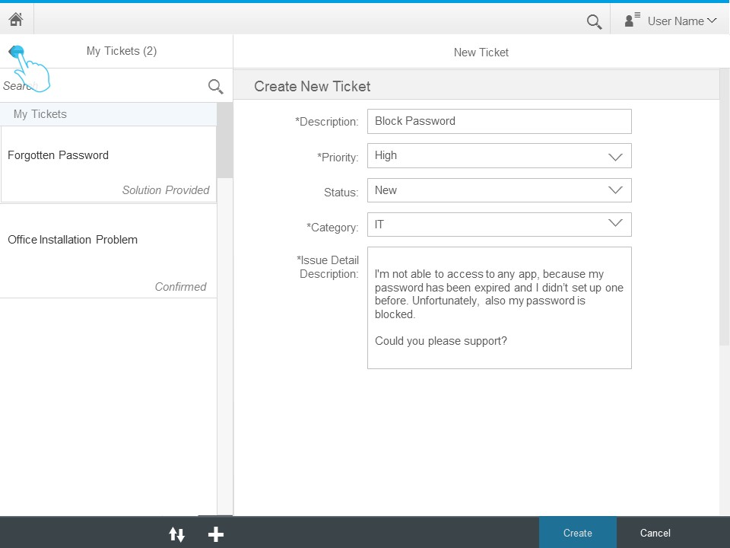
Figure 10 Create New Ticket

Support Team Member

Login
Following figure displays the login screen of the Support Ticketing System. Based on the entered user credentials, role of the user will be identified and next screen will be displayed based on the role of the user.
Figure 10 Login

Home Screen for Support Team Members
On the initial screen of support team members, three links will be displayed; solution category, support solutions, open tickets.
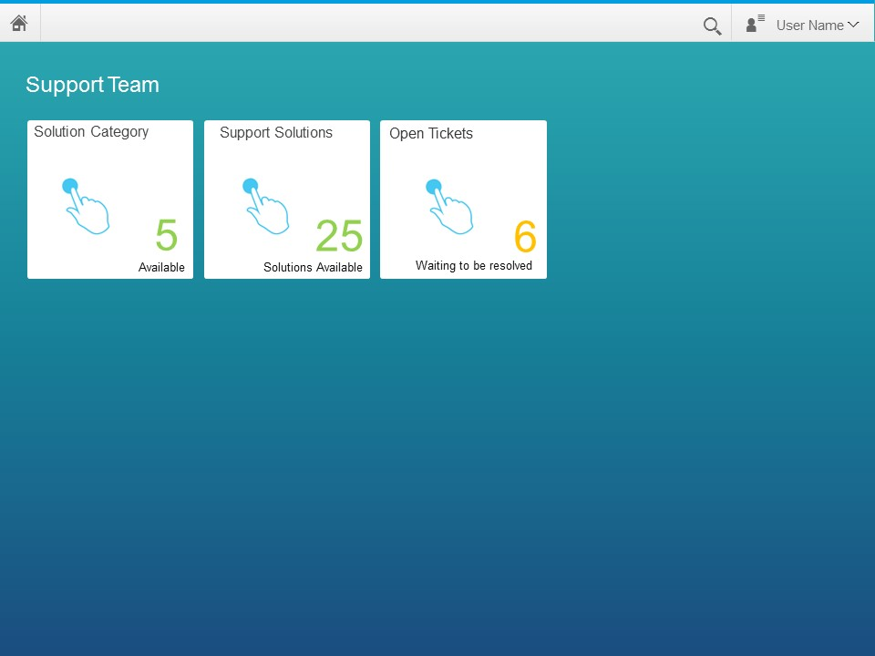
Figure 11 Home Screen for Support Team Members

Solution Category
This screen consists of two panes. On the left pane, categories which include predefined support solutions will be displayed. Based on the choice of the support team member, the details of the selected category is displayed on the right pane of the screen.

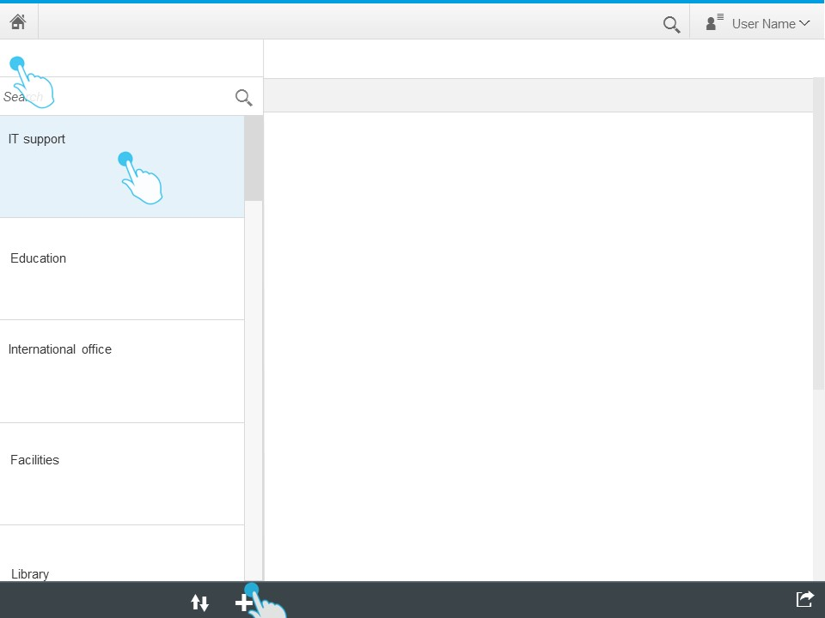
Figure 12 Solution Category Maintenance
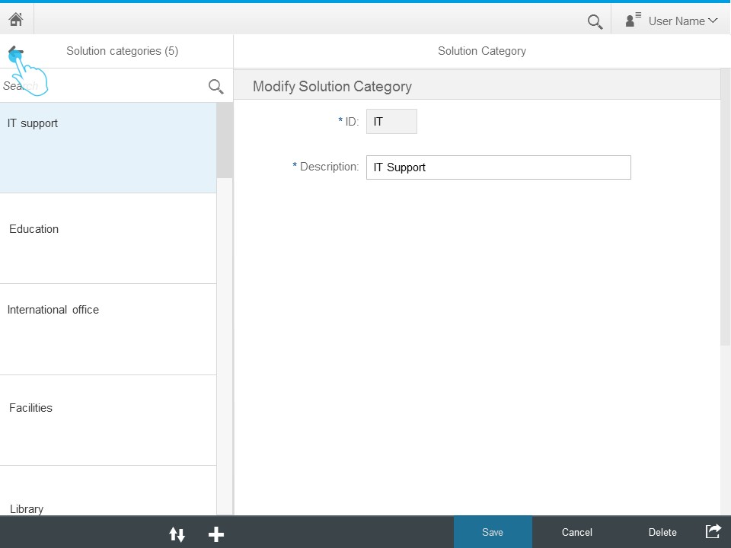
Figure 13 Solution Category Details

New Solution Category
When the support team member clicks on the plus button which is located bottom at the bottom of left pane, new solution category form will be displayed on the right pane of the screen. To create a new solution category, id and description fields should be inputted.

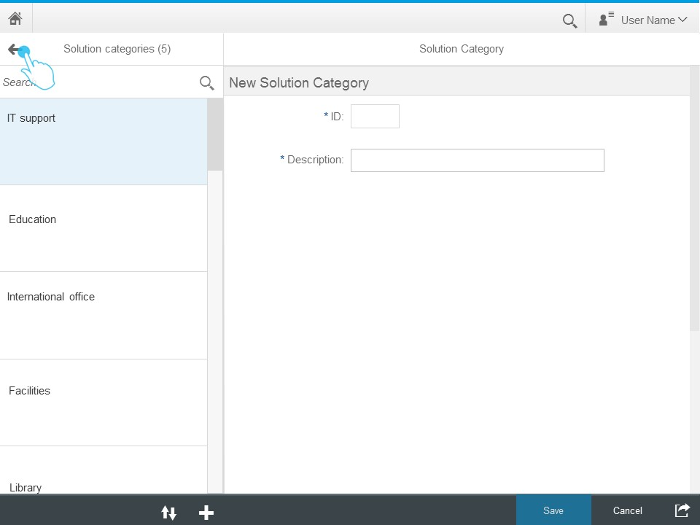
Figure 14 New Solution Category

Support Solutions
This screen consists of two panes. On the left pane, categories which include predefined support solutions will be displayed. Based on the choice of the support team member, the predefined solutions of the selected category are displayed on the right pane of the screen.

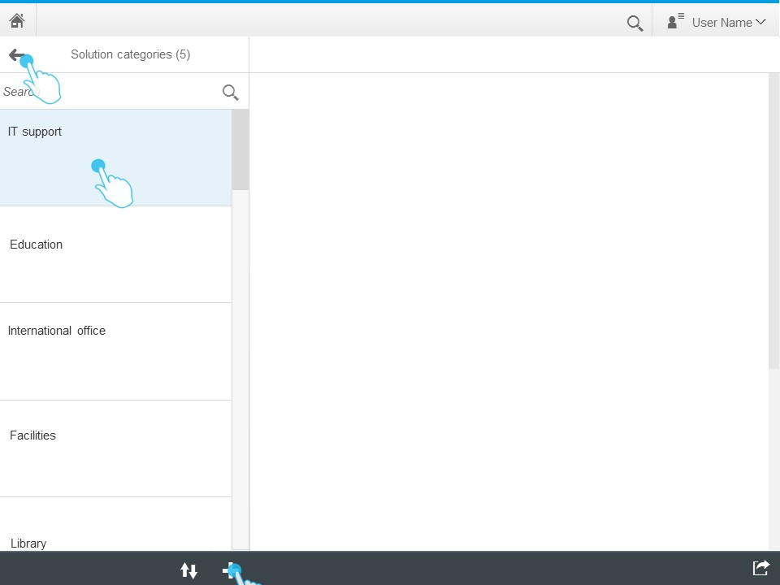
Figure 15 Predefined Support Solution Maintenance
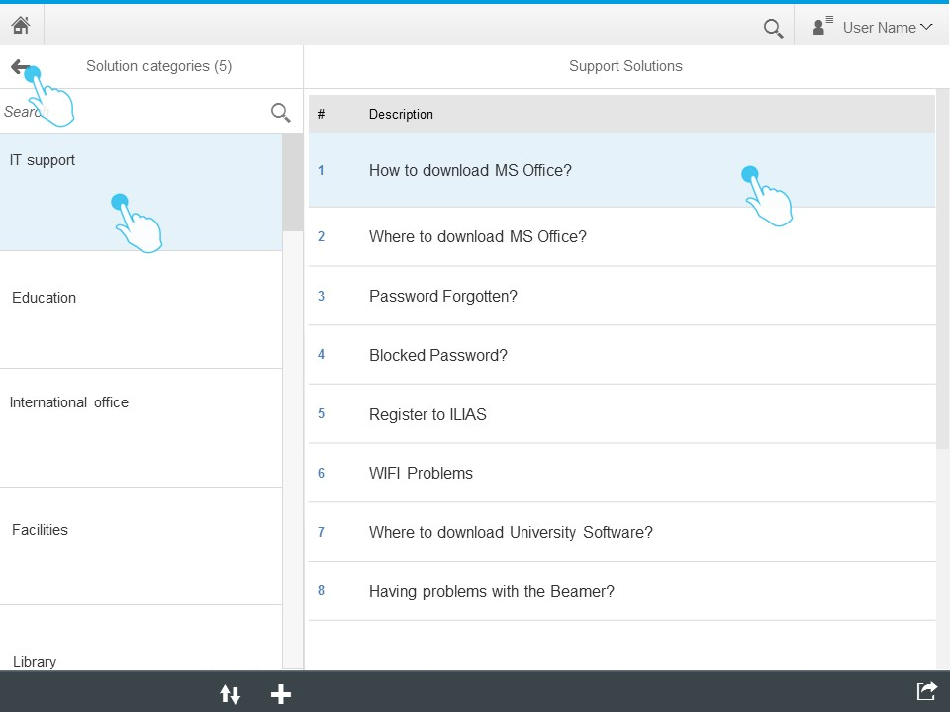
Figure 16 Predefined Support Solutions Maintenance 2

Modify Support Solutions
When support team member clicks on a predefined support solution description, which is listed on the right pane, the details of the selected predefined support solution will be displayed on the right pane of the screen. Here, the predefined support solution can be modified and saved.
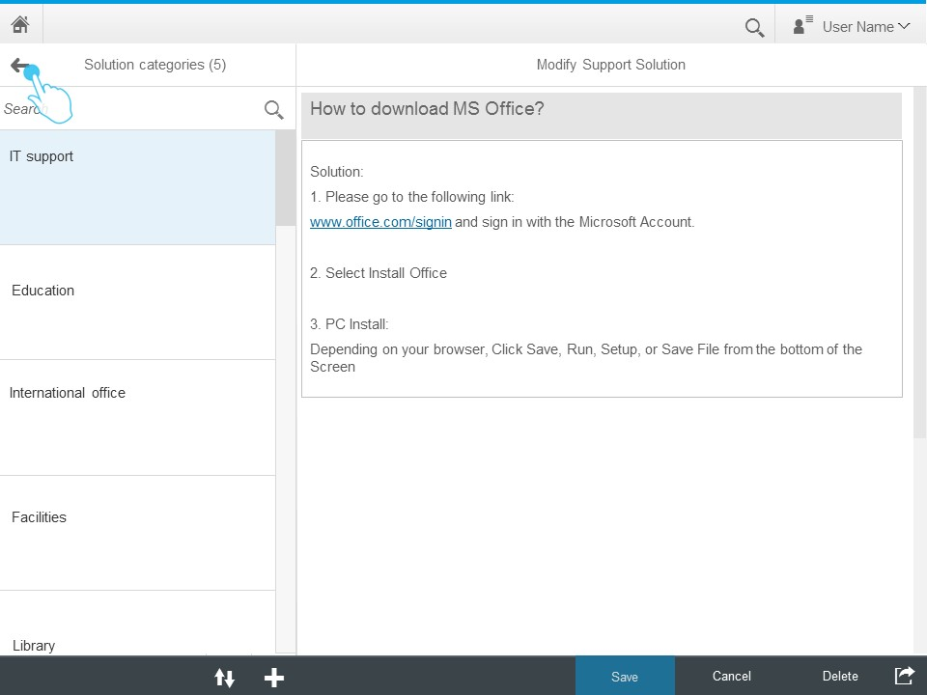
Figure 17 Predefined Support Solutions

New Support Solutions
When the support team member clicks on the plus button, which is located at the bottom of left pane, new support solution form will be displayed on the right pane of the screen. To create a new support solution, issue description, category and solution description fields should be inputted.

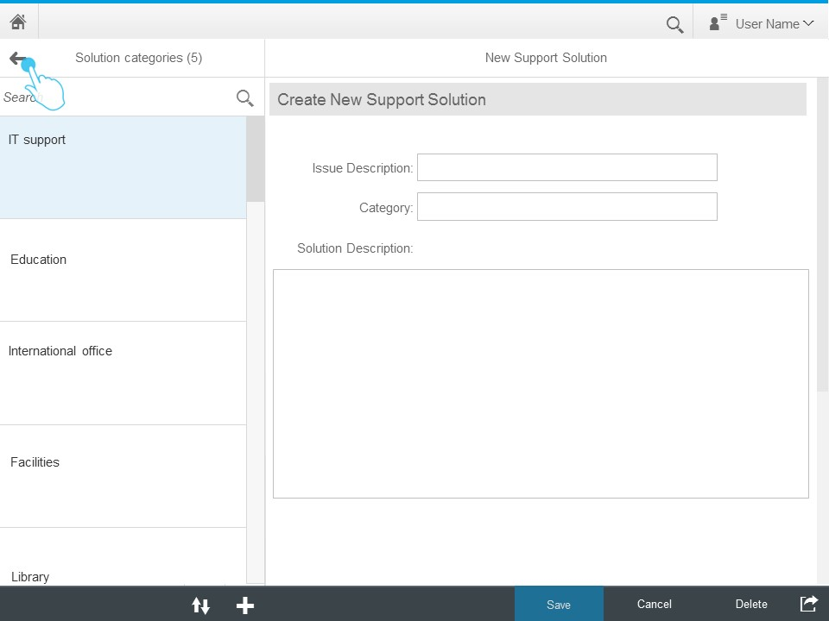
Figure 18 New Support Solution

Open Tickets
This screen consists of two panes. On the left pane, descriptions of the open tickets will be listed. When the support solution member clicks on a specific open ticket, details of the selected ticket will be displayed on the right pane. To provide support, the support team member will fill the solution field and click on send button.

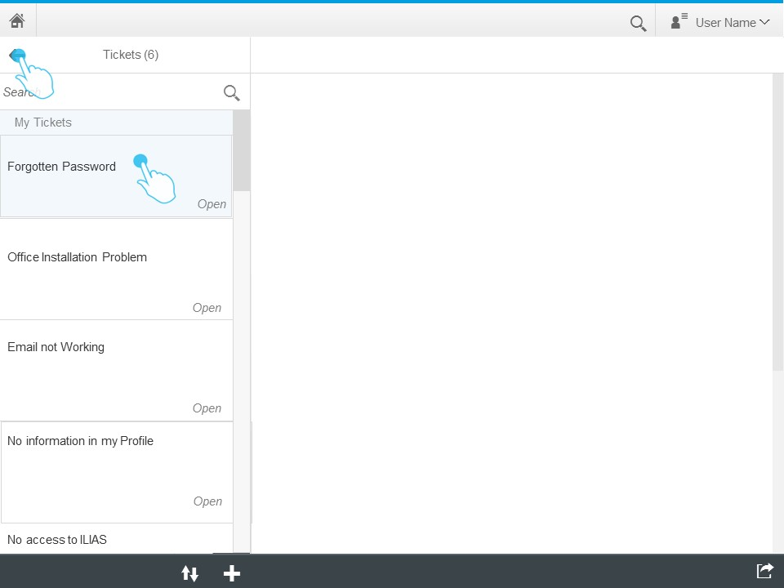
Figure 19 Open Tickets List
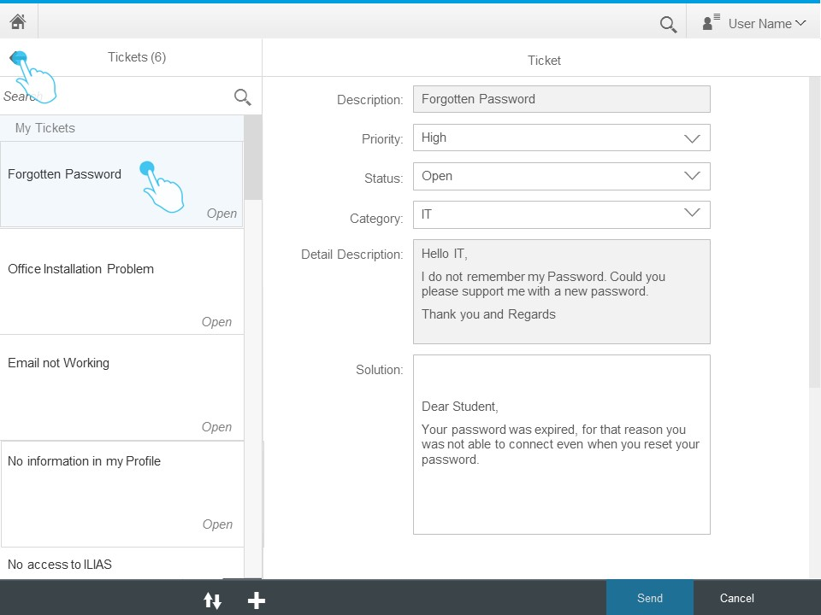
Figure 20 Open Ticket Details

Support Team Manager

Login
Following figure displays the login screen of the Support Ticketing System. Based on the entered user credentials, role of the user will be identified and next screen will be displayed based on the role of the user.
Figure 21 Login

Home Screen for Support Team Manager
On the initial screen of the support team manager, two links will be displayed; assign responsible and team performance analytics.

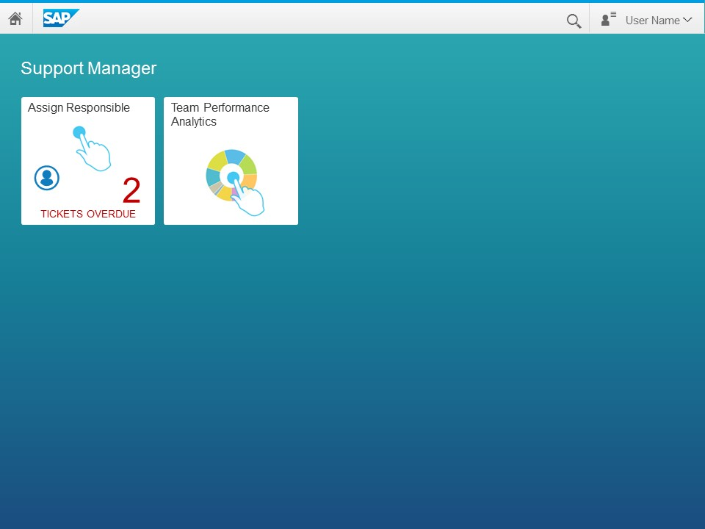
Figure 22 Home Screen for Support Team Manager

Assign Responsible
The overdue tickets, which are still open after 48 hours, will be displayed on this screen. This screen consists of two panes. On the left pane, the description of the open overdue tickets will be listed. Based on the selection of the solution manager, the details of the selected ticket will be displayed on the right pane.
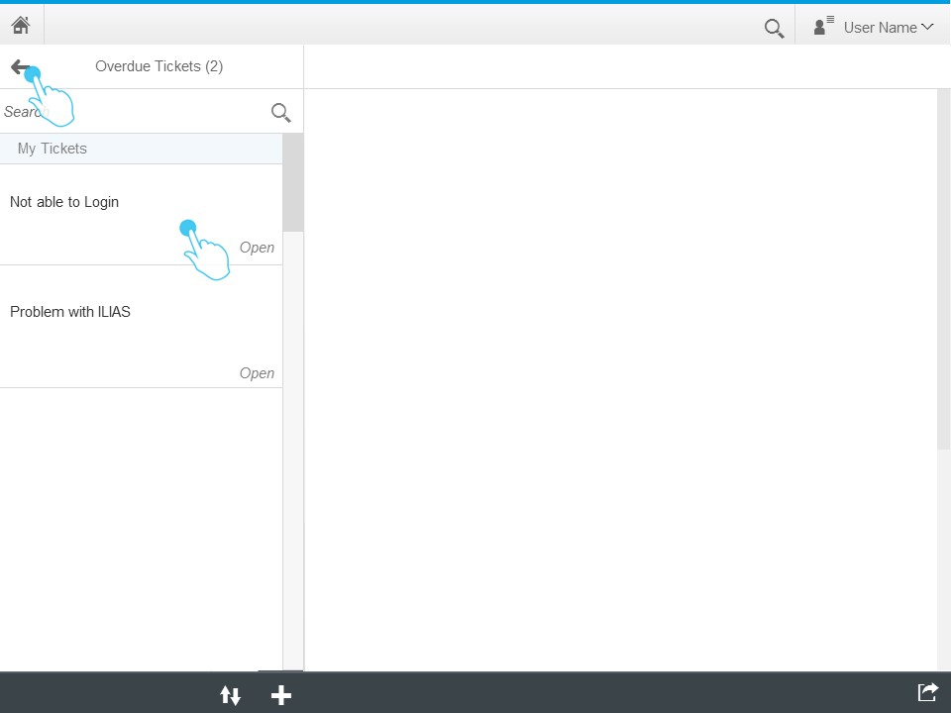
Figure 23 Overdue Tickets List
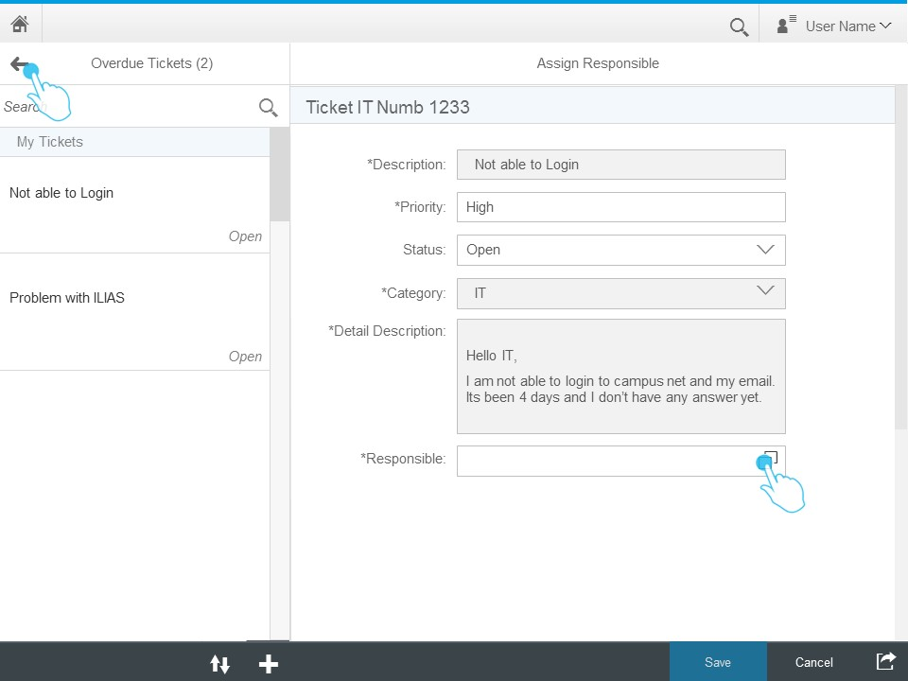
Figure 24 Overdue Ticket Details
By selecting a support team member from the list of responsible, the support team manager can assign the ticket.
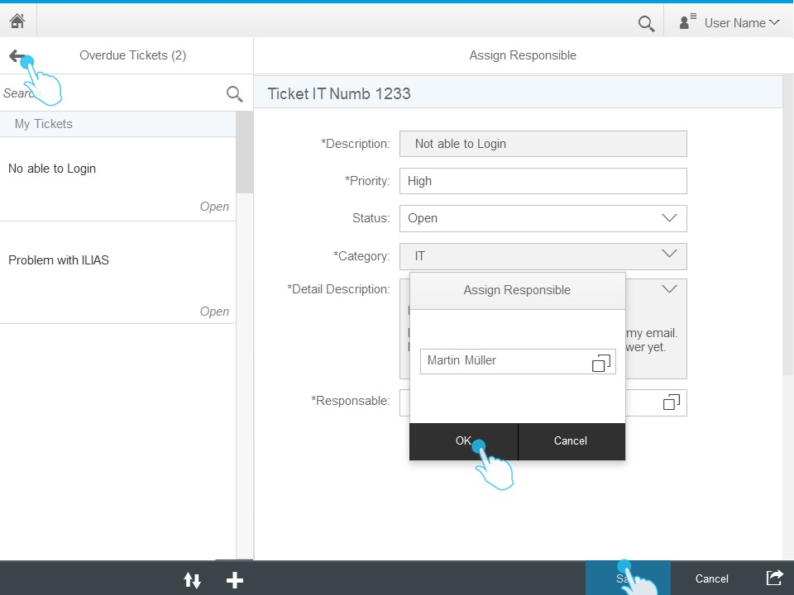
Figure 25 Overdue Ticket Responsible Selection
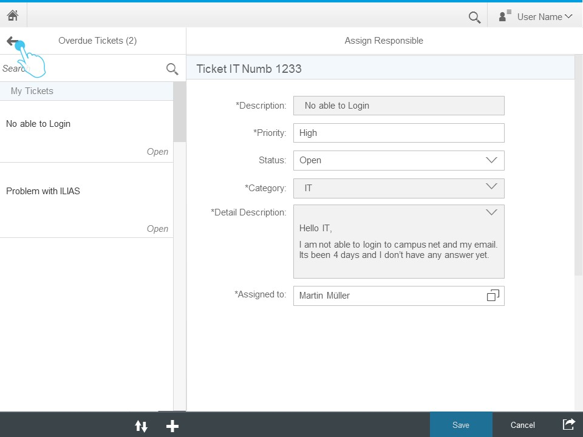
Figure 26 Overdue Ticket Assignment

Team Performance Analytics
On the team performance analytics screen, the solution team manager can view analytics for tickets based on their status or rating which will be calculated by the feedback results of students. The results can be filtered by a specific period and/or a specific support team member.
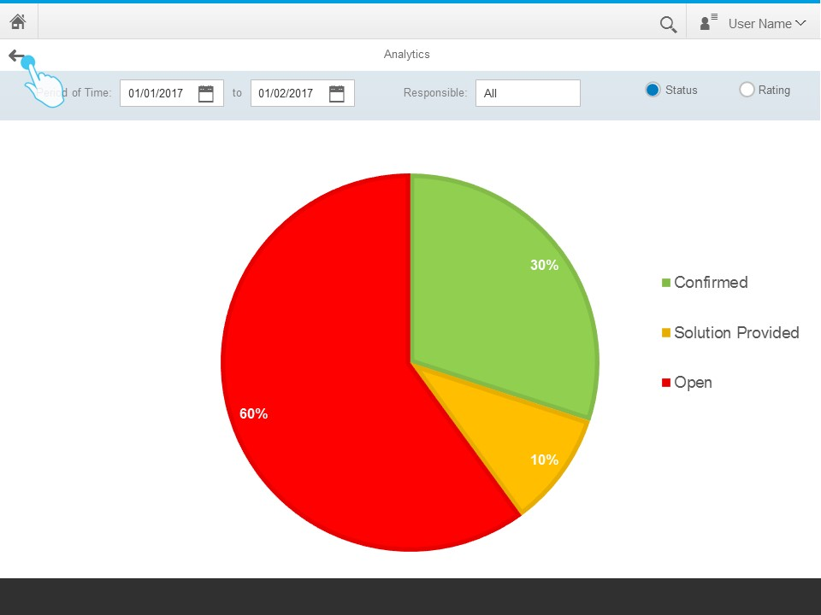
Figure 27 Team Performance Analytics

Roles and Authorizations
The Support Ticketing System supports the prebuild SAP Cloud Platform authorization concept, therefore additional logic is not needed. Nevertheless, there are two separate authorization concepts for backend and frontend layer. In general, there are three different roles which require varying levels of authorization: end-users, support team members and managers. On the backend level this is realized by the creation of three different roles in the App Layer. On the frontend level the administrator manages the user access to the Support Ticketing System application by using the role-based authorization concept provided by SAP Cloud Platform. To enable the role based access to an application in a site, roles must be assigned to the catalog, or to groups which are then assigned to the catalog. First it is possible to assign roles directly to a user, but this makes administration quite expensive. Therefore, it is also possible to create user groups and assign roles to these groups. A user will then be assigned to a group and the inherit roles. So, there are two possibilities. 1.) Assign roles to a catalog so that a user with a specific role can access an app in a site. 2.) Assign roles to a group, in that case users with this role can view the group in their launchpad and can launch apps in the group. In both cases the users can only access the app (in the group), if the app is assigned to the same catalog as the user’s role. Figure Figure 28 Roles and Authorizations illustrates this role-based authorization concept implemented in the SAP Cloud Platform. (SAP, 2017d)
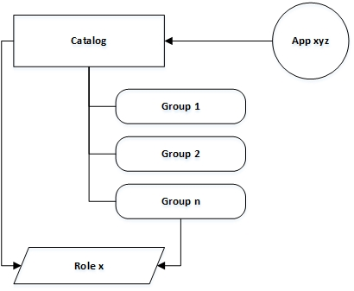
Figure 28 Roles and Authorizations

Database diagram (ERM)
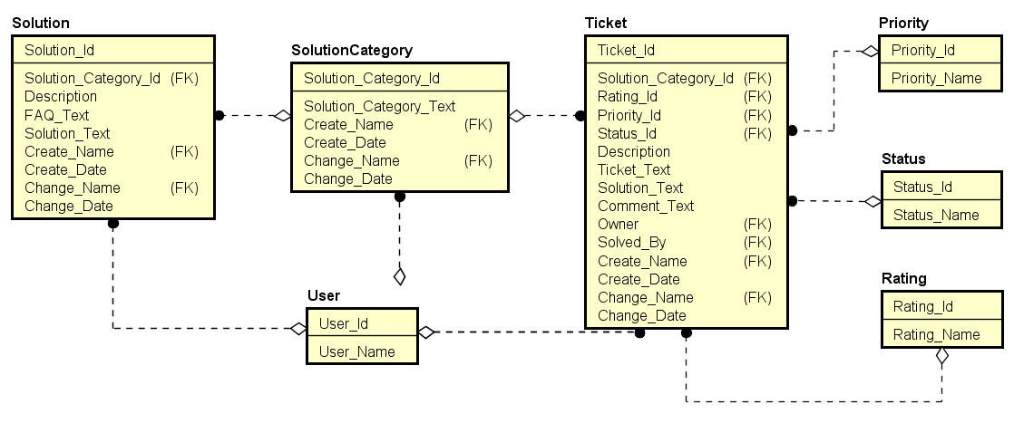
Figure 29 ERM Support Ticketing System

Error: Reference source not found shows the basic Entity Relationship Model for the Support Ticketing System and thereby its database structure. The model consists of seven main entities: Solution, Solution Category, User, Ticket, Priority, Status and Rating. All relationships are non-identifying relationships, because each of the entities can exist without the others. This design allows e.g. the creation of a new Ticket without specifying a Rating, or to delete an old entry in Ratings that is not needed anymore, even though there are still Tickets using this Rating entry. Additionally, every entity has exactly one primary key with the naming convention Entityname_Id. The entity User holds only an id and a value filed with the user’s name. The same applies to the entities Priority, Status and Rating. The Solution entity has a foreign key entry for the solution category, a description, FAQ text and a solution text. Every Solution belongs to a certain Solution Category, but a Solution Category can belong to many Solutions. The three main entities of the database model Solution, Solution Category and Ticket also all have attributes for the creation date as timestamp, the last modification date as timestamp and for both a foreign key related to the user entity, that specifies the user that was creating or changing a record. Ticket additionally holds another two attributes Owner and Solved_By, which are foreign key references to the User entity. These two specify the owner of a ticket and by whom the ticket was solved in the end. Furthermore, every Ticket has a Priority, a Status and a Rating, therefore Ticket has another three references to foreign entities. And just as Solution, every Ticket is assigned to one single Solution Category. Beside these foreign key references the Ticket entity has a description, ticket text, solution text and comment text attribute.

References
Andreas Kunz, 2013. What is OpenUI5 / SAPUI5 ? [online]. 11 December 2013, 12:00 [viewed 15 April 2017]. Available from: https://blogs.sap.com/2013/12/11/what-is-openui5-sapui5/
Janina Bläsius, 2016. Developing Web Apps with SAPUI5 [online]. 29 June 2016, 12:00 [viewed 17 April 2017]. Available from: https://open.sap.com/courses/ui51
Karl Kessler, 2015. SAP NetWeaver 7.5 [online]. 21 September 2015, 12:00 [viewed 17 April 2017]. Available from: https://archive.sap.com/documents/docs/DOC-67587
ODATA, 2015. OData - the Best Way to REST [online]. OData - The Protocol for REST APIs [viewed 15 April 2017]. Available from: http://www.odata.org/
Raz Korn, 2016. Build Your Own SAP Fiori App in the Cloud [online]. 5 May 2016, 12:00 [viewed 12 April 2017]. Available from: https://open.sap.com/courses/fiux2
SAP, 2016a. Design Stencils [online]. SAP Fiori Design Guidelines. 11 November 2016, 12:00 [viewed 12 April 2017]. Available from: https://experience.sap.com/fiori-design-web/downloads/
SAP, 2016b. SAP Cloud Platform Documentation [online]. Overview [viewed 15 April 2017]. Available from: https://help.hana.ondemand.com/help/frameset.htm?e7c9982cbb571014a97a8a675cf28c15.html
SAP, 2017a. BUILD [online] [viewed 12 April 2017]. Available from: https://www.build.me/splashapp/
SAP, 2017b. Database and Data Management - SAP Adaptive Server Enterprise [online] [viewed 17 April 2017]. Available from: https://www.sap.com/germany/product/data-mgmt/sybase-ase.html
SAP, 2017c. SAP Cloud Platform [online]. SAP Cloud Platform Cloud Connector [viewed 17 April 2017]. Available from: https://help.sap.com/viewer/65de2977205c403bbc107264b8eccf4b/Cloud/en-US/e6c7616abb5710148cfcf3e75d96d596.html
SAP, 2017d. SAP Cloud Platform Portal [online]. About Roles [viewed 18.04.5017]. Available from: https://help.sap.com/viewer/3ca6847da92847d79b27753d690ac5d5/Cloud/en-US/1e5d10b9f00a4e1aac73f2aaf8334798.html
SAP, 2017e. SAP Fiori Design Guidelines [online]. SAP Fiori and Design Principles. 11 November 2016, 12:00 [viewed 12 April 2017]. Available from: https://experience.sap.com/fiori-design-web/design-principles/
Wikipedia, 2017. Multitier architecture [online]. 27 March 2017, 12:00 [viewed 17 April 2017]. Available from: https://en.wikipedia.org/wiki/Multitier_architecture

